All Creative Designs

Basic HTML for PC Tutorial Part 2
Using MS Notepad
Revised Version May 2013

My First Web Page

This tutorial will add backgrounds to the table and body, font colors, borders, hyperlinks and more to your web page created in Basic HTML for PC Tutorial Part 1

We didn’t specify a font color or body color in our first web page tutorial and so by default the internet browser will show a white body background, the font type will be Times New Roman in black and no borders are shown. To change this we will add extra elements within our HTML tags. Duration of this tutorial is approximately 40 - 50 minutes.

Table of Content

Step 1: Open your index.html file in Notepad 2
Step 2: Saving a tiling background image for your web page 3
Step 3: Adding a tiling body background image 4
Step 4: Adding a tiling background to your table 5
Step 5: Table layout 6
Step 6: Apply formatting to rows, cells and text 6
Adding a background color to a table row or cell and change font color 6
Step 7: Adding hyperlinks and e-mail addresses 8
Hyperlinks to other web sites 8
Links to E-mail addresses 9
Step 8: Trouble Shooting 10

Step 1: Open your index.html file in Notepad

Open your index.html file we created in Part 1
Navigate to your index.html file and single right click, select Open With and left click Notepad. If Notepad does not appear on the list; click Choose Program and locate it on the provided list.

(See Figure 1)

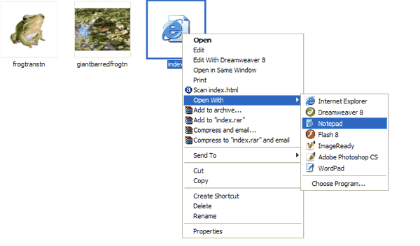

Figure 1

Step 2: Saving a tiling background image for your web page

A tiling background is a small thumbnail sized image repeating vertically and horizontally to fill the whole screen (body) or a table, i.e. tiling it. The tiling background image file we are using is only less than 2KB in size. It is only downloaded once and repeated by internet web browsers, therefore loading speed of your web page is only minimally increased and interesting effects can be created.

Download and save a tiling background image from our web site.
Go to our Background Gallery page and click on Backgrounds Folder Page 3:
Control click link below:
http://www.allcreativedesigns.com.au/ pages/gallbackgrounds3.html
You might have to type or copy and paste this address into your browser if viewing the PDF version

1. Scroll down and left click Tiling Background ‘Water Aqua’.
2. Right click the new small window and select Save Picture As…
Make sure you right click directly over the image; otherwise the option of Save Picture As will not show.
3. Navigate to your my_fisrt_web_page folder and click Save.
If you like choose any background suiting your web page from the ‘Tiling Backgrounds’ on display.

Repeat the process with a second background tiling image, in this example we use ‘Green Fading’ marked as 4.
Make sure you right click directly over the image (thin strip); otherwise the option of Save Picture As will not show.
(See Figure 2)

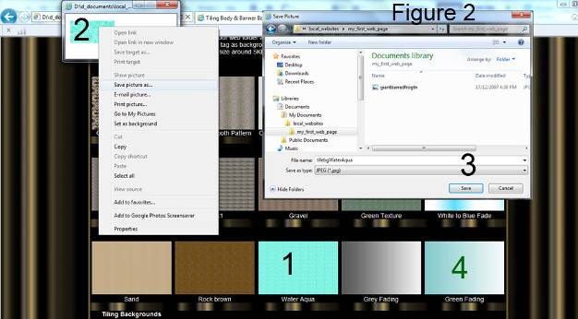

Step 3: Adding a tiling body background image

Link to your saved tiling image by adding to the body tag in your index.html file:
<body background=”tilebgWaterAqua.jpg”>
(Figure 3)

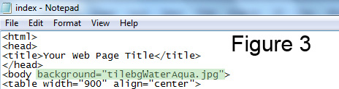

This will set your body background using the above image.

In your notepad index.html document click file in top menu bar and click save.

In windows explorer (My Computer) navigate to your my_first_web_page folder and double left click your index.html file. Your web page should open in your default web browser i.e. Internet Explorer or Mozilla Fire Fox.
(Figure 4)

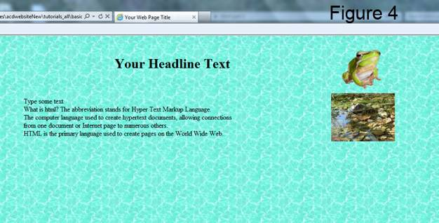

If you prefer to set your body background to an even color use the addition below instead:
<body bgcolor=”blue”>
All basic colors will work; try aqua, cyan, pink or others.
Specifying color by Hexadecimal Code is explained in Part 3 of this tutorial.

Step 4: Adding a tiling background to your table

Add to the table tag in your index.html file:
<table width”900” align=”center” background=”tilebgFadegreen2H.jpg” border=”1”>

(See Figure 5)

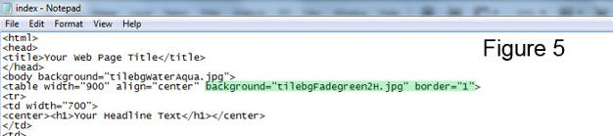

This will link your table to the tiling background image and create borders around the table and cells at size 1 (smallest).

Do not copy and paste from MS Word, type yourself and check your spelling.

In your notepad index.html document click file in top menu bar and click save.

In windows explorer (My Computer) navigate to your my_first_web_page folder and double left click your index.html file. Your web page should open in your default web browser i.e. Internet Explorer or Mozilla Fire Fox.

View of updated web page
(See Figure 6)

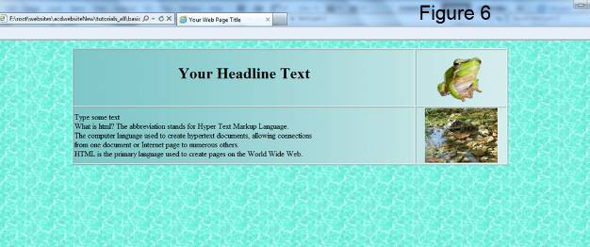

You might like to repeat the process with different tiling backgrounds of your choice.

Step 5: Table layout

In step 4 we added a border to the table which shows the layout of your web page.

The graphic below shows how all html tags are read and displayed by an internet browser.

(See Figure 7)

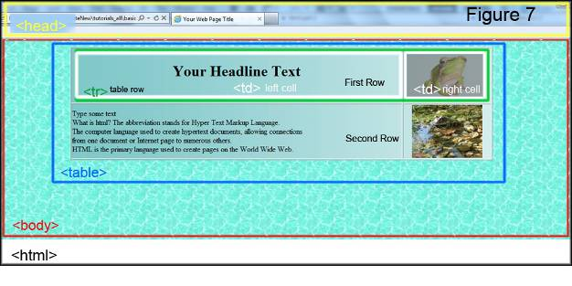

You might not want to show any borders, to do this change to border=”0”.
<table width”900” align=”center” background=”tilebgFadegreen2H.jpg” border=”0”>

Step 6: Apply formatting to rows, cells and text

Adding a background color to a table row or cell and change font color

Continue with the second row tag (new addition are shown in green)
</tr>
<tr bgcolor=”black”>
<td>
Note color is spelled without the u, the American way, spelling it colour will not work.
This will set the background color of the second row to black.
In the same way background color can be set for individual cells <td bgcolor=”green”>.

As our text font is black by default it will disappear, so we will change it to white.
To do this wrap font color tags around your text:
<font color=”white”>Type some text</font>
(See Figure 8, next page)
Specifying font and background colors by name:
All basic colors will work; try aqua, cyan, pink or others. Specifying color by Hexadecimal Code will be covered later.

Inserting line breaks into your text:
Use the <br /> tag to start a new line of text. The <br /> tag can be used for spacing in your web page, add three break tags after your last word of text to create a space below. Note: There is no closing tag as forward slash is included in the break tag. If you don’t use line break tags <br />, text will wrap to the set cell width.

It is possible to copy text (not html tags) from MS Word and paste it into your notepad file between html tags only.
Your notepad index.html document should look similar to this:
(See Figure 8)

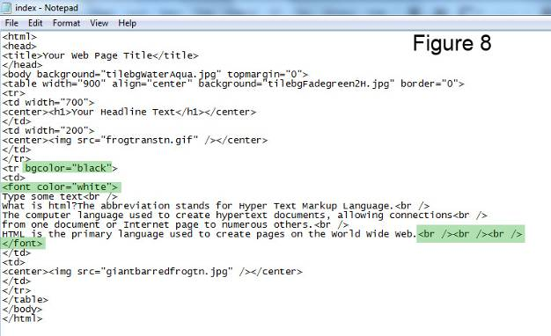
Save your updated web page:
In your notepad index.html document click file in top menu bar and click save.

View your web page:
In windows explorer (My Computer) navigate to your my_first_web_page folder and double left click your index.html file to view your updated web page. Your web page should look similar to this (See Figure 9, next page)

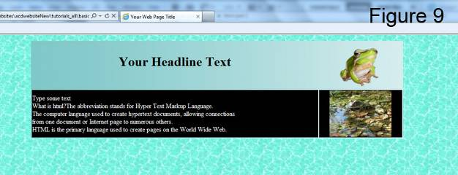

To eliminate the gap on top of your webpage insert a top margin into the body tag.
<body background=” tilebgWaterAqua.jpg” topmargin=”0”>

To center your images, headlines or text in their cells wrap a center tag around your image tags, headline tags or text.
Example: <td><center><img src=”image_file_name.jpg” /></center></td>

Step 7: Adding hyperlinks and e-mail addresses

Hyperlinks to other web sites

Insert three line breaks after your last word in the text cell (if you haven’t done so before). To link your web page to other web sites use the following code, make sure you insert the link below (or after) the closing font tag:

<td>
Your Text<br /><br /><br />
</font>
<a href=”http://www.google.com.au” target=”blank” >Google Link</a>
</td>

Clicking the text Google Link in your web page will open the Google Home page in your internet browser. Inserting target=”blank” will open Google in its own browser window. By default links are shown in blue color, purple after been visited and are underlined.

Links to E-mail addresses

If you like to be contacted through your e-mail address include the code below.
After the Google link type two <br /> tags:
<a href=http://www.google.com.au target=”blank” >Google Link</a><br /><br />
<a href=”mailto:username@yourdomain.com.au”>Contact me</a>
</td>
Use your own e-mail address.

Clicking Contact Me will open e-mail software like Outlook Express or Windows Mail (if configured) with your e-mail address inserted.

Your notepad index.html document should look similar to this:
(See Figure 10)

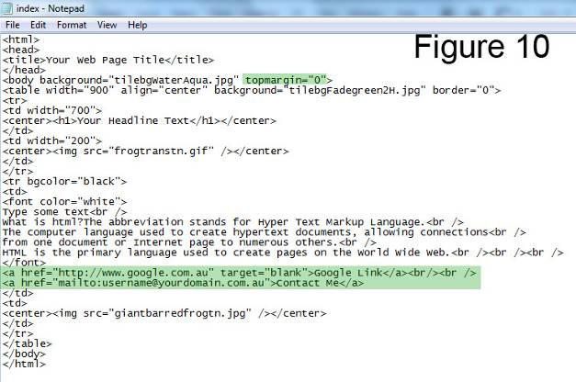

In your notepad index.html document click file in top menu bar and click save.
In windows explorer (My Computer) navigate to your my_first_web_page folder and double left click your index.html file. Your web page should open in your default web browser i.e. Internet Explorer or Mozilla Fire Fox.
View your web page:
(See Figure 11)
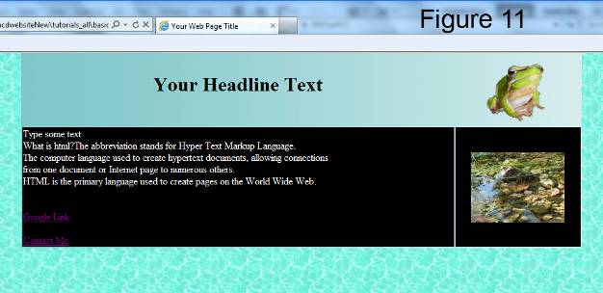

Step 8: Trouble Shooting

Your script might not work properly if you copied and pasted html tags from MS Word.
My image(s) will not show :
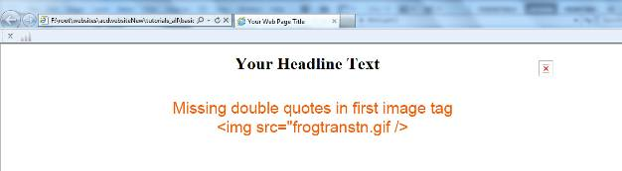
X
Possible causes:
1. Missing or incorrect quotes
2. Spelling mistakes or spaces in file names
3. Wrong file extension i.e. .jpg instead of .gif
4. Images are not saved in the same folder than your index.html file
5. Used double typed single quotes/apostrophes instead of inverted commas/double quotes
Inverted commas/double quotes on your keyboard

Positioning of elements incorrect:
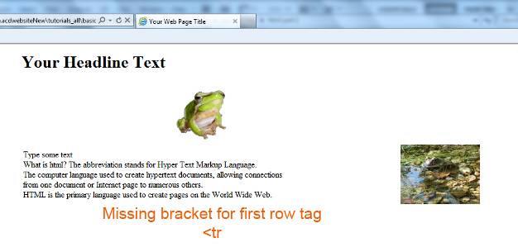
Possible causes:
1. Missing bracket for tags
2. No forward slash in closing tag
3. Incorrect spelling or spaces within html tags
4. Used double apostrophes instead of inverted comas

Google home page will not load after clicking the link:
- Make sure your internet connection is working
- In your internet browser check the address bar on the top and see if Google address is correct: http://www.google.com.au
If necessary make changes to your index html file and save, then try again.

Most errors are caused by spelling mistakes and added or missing spaces in HTML tags. Check for missing inverted comas and closing tags.

If you find mistakes in your index.html code make the necessary changes and save again. If your web page is still open in your browser just click refresh otherwise reopen your web page

The third part of this tutorial explains:

How to create another web page and link it to your homepage.
(The start of a little web site)

Specifying color by Hexadecimal Code

How to use your own images

List of useful html tags and more

Have fun with your web page and experiment with different images, backgrounds and colors.
Other tutorials available from www.allcreativedesigns.com.au
You might have to type or copy and paste this address into your browser if viewing the PDF version

www.allcreativedesigns.com.au/pages/tutorialbasicp1.html
HTML Web Page Tutorial using Notepad, PDF Download Page Part 1

www.allcreativedesigns.com.au/pages/tutorialbasicp3.html
Free PDF HTML Tag Tutorial using Notepad, Download Page Part 3

www.allcreativedesigns.com.au/pages/webtutorialkompozer.html
Web Design Tutorial using KompoZer, PDF Download Page

www.allcreativedesigns.com.au/pages/tutorialpicasa.html
Picasa Photo Editing Tutorial, Free PDF Download Page

www.allcreativedesigns.com.au/pages/tutorialseo.html
SEO Tutorial Basic Search Engine Optimization PDF Download Page

