All Creative Designs

Basic HTML for PC Tutorial Part 3
Using MS Notepad
Revised Edition May 2013

My First Web Page

This tutorial uses the index.html file together with saved images created in part 1 and 2 of basic html tutorials using notepad. It is necessary to complete these tutorials or have a prior basic understanding of html tags to understand the instructions.

The third part of this tutorial explains:

- How to create another web page and link it to your home page.
(The start of a little web site)
- Create your own web photo album.
- How to use your own images and link them
- Specifying color by hexadecimal code
- List of useful html tags and more

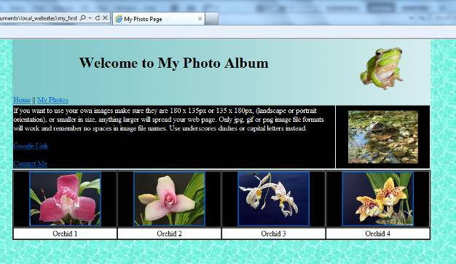

Table of Content

Step 1: Open your index.html file 3
Step 2: Creating another web page 4
1. Include a link to your new page and to the home index.html page 4
2. Saving your new web page 5
Step 3: Making changes to your photopage.html 7
Step 4: Inserting a new table 9
Step 5: Creating a photo album 10
1. Saving web optimized images into your web page root folder 10
2. Downloading images from our web site 11
3. Inserting thumbnail images 12
4. Hyper linking your images 14
5. Trouble Shooting: 15
6. Inserting a row for descriptions or titles: 15
Finished photopage.html notepad document: 17
Specifying color by Hexadecimal Code 17
More useful HTML tags 18
Trouble Shooting: 18
Other tutorials available 20

Step 1: Open your index.html file

Open your index.html file we created in Part 2
Navigate to your index.html file and single right click, select Open with and left click Notepad.
(See Figure 1)

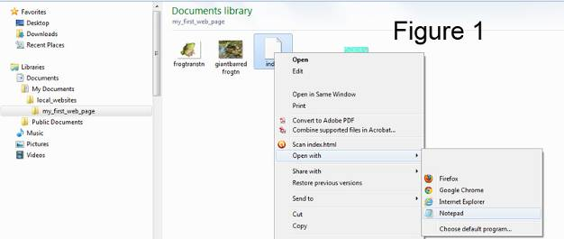

The index.html we created in Part 2:
(See Figure 2)

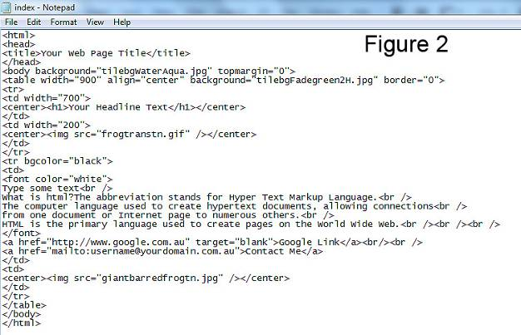

Step 2: Creating another web page

1. Include a link to your new page and to the home index.html page

To prominently place the link to your new page on the index (home) page we will add a new table row below the headline row. Into the first (new) cell we place our links to the home and the new page we are going to build. In this example we are calling our new page photopage.html, but if you like change it to suit your purpose. Remember to name your new html page without spaces or special characters followed by the .html file extension.
To insert 2 vertical lines for visual separation of links; press Shift and straight slash above the Enter key on your keyboard twice. Type only text shown in green.

<center><img src="frogtranstn.gif" /></center>
</td>
</tr>
<tr>
<td width="700">
<a href="index.html">Home</a> || <a href="photopage.html">My Photos</a>
</td>
<td width="200">
</td>
</tr>
<tr bgcolor="black">
(See Figure 3)
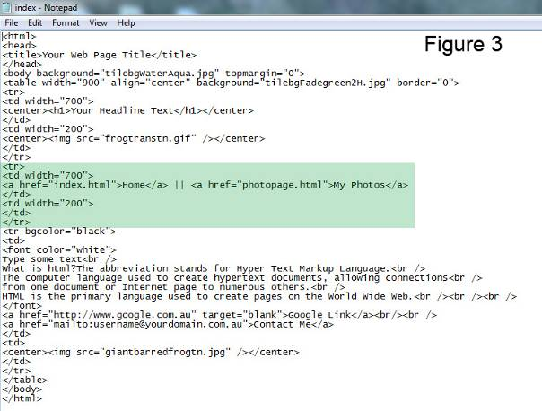
In your notepad index.html document click file in top menu bar and click save.

In windows explorer (My Computer) navigate to your my_first_web_page folder and double left click your index.html file to view your updated web page.
(See Figure 4)

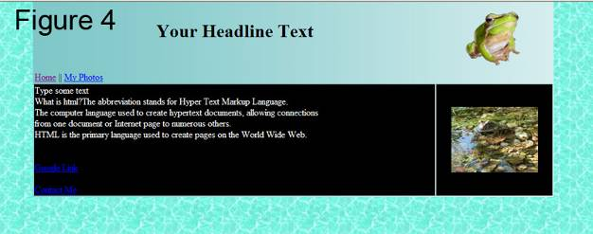

By default links are shown in blue color, purple after been visited and are underlined.

2. Saving your new web page

Instead of having to type a whole new html document we will use the Save As command to create a copy of the index (home) page and convert it to our new purpose.

In the index.html notepad file:
1. Click Save As under the File menu.
2. Navigate to your web folder
3. Select All Files under Save as type
4. Type a name for your new page without spaces or special characters followed by .html extension, here we use photopage.html
(Make sure of identical spelling with the new page link in the index page)
5. Click Save

(See Figure 5, next page)
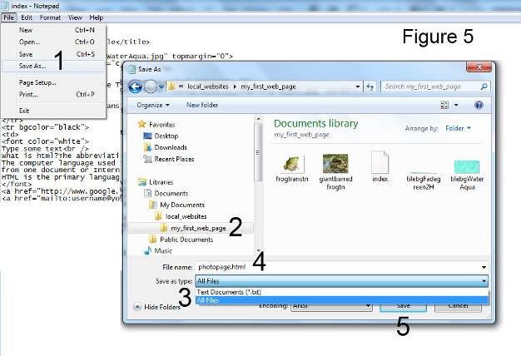

Your photopage.html opens in notepad
(See Figure 6)

Step 3: Making changes to your photopage.html

In your photopage.html file change the text in between the title tags to My Photo Page then change text in between headline <h1> tags to Welcome to My Photo Page. Make sure title <title> and headline <h1> tags stay intact.
Select all text as shown below and right click then select Delete or press delete on your keyboard.

You might like to insert new text in this place describing your web page content. Make sure text shows in between <font color”white”> and </font> tags. Type two <br /> tags at the end of your new text to create a space before your Google link.

It is possible to copy text (not html tags) from MS Word and paste it into your notepad file between html tags only.

(See Figure 7)

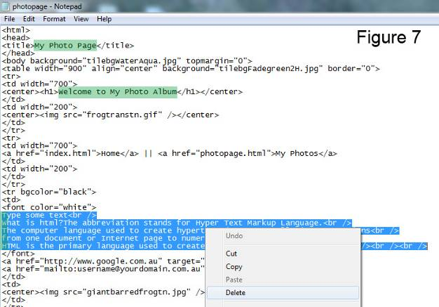

In your notepad photopage.html document click file in top menu bar and click save.

View your web page:
In windows explorer (My Computer) navigate to your my_first_web_page folder and double left click your photopage.html file to view your updated web page. There click your home link and your index. html page should appear. If your web page is still open in your internet browser just click refresh.
(See Figure 8)

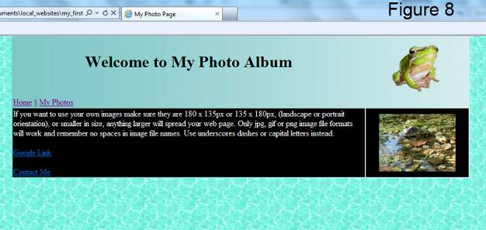

If you want to use your own images make sure they are 180 x 135px or 135 x 180px, (landscape or portrait orientation), or smaller in size, anything larger will spread your web page. Only jpg, gif or png image file formats will work and remember no spaces in image file names. Use underscores dashes or capital letters instead. GIF images can have transparent backgrounds as frogtranstn.gif used in this tutorial.
Make sure all images are saved in your web root folder (my_first_web_page folder).

Follow the Image Editing Tutorial using Picasa and save web optimized copies of your images into your my_first_webpage folder. See links at end of this tutorial.

Trouble Shooting:

Cannot find server / The page cannot be displayed error message:
Make sure of identical spelling of the link in the index page with the actual name of your new page (i.e. photopage.html).

Most errors are caused by spelling mistakes and added or missing spaces in HTML tags. Check for missing inverted comas and closing tags.

Step 4: Inserting a new table

This step will create another table with one row and four cells beneath your first table to hold more content in a different layout. The table is going to be 900 pixels in width and centered with borders at size”1” and black background showing. In the next step we will insert more images and links into this new table to start of a photo album.
Type the code below beneath your closing </table> table tag and above the closing </body> body tag. The <br /> tags will force the cells to expand before we include more content. (By default table rows without any content will collapse and aren’t visible.)
</table>
<table width="900" align="center" border="1" bgcolor=”black”>
<tr>
<td><br /></td>
<td><br /></td>
<td><br /></td>
</tr>
</table>
</body>

(See Figure 9)
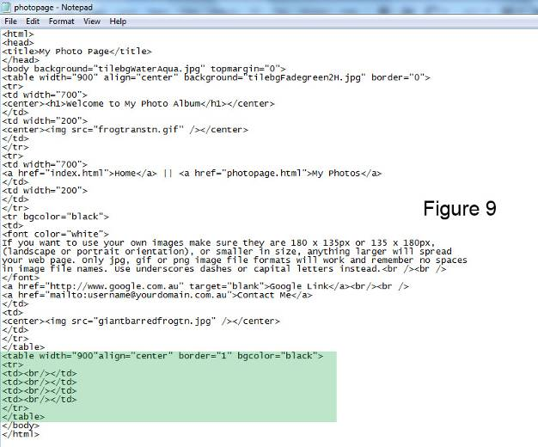

In your notepad photopage.html document click file in top menu bar and click save.

In windows explorer (My Computer) navigate to your my_first_webpage folder and double left click your photopage.html file to view your updated web page. If your web page is still open in your internet browser just click refresh.

(See Figure 10)

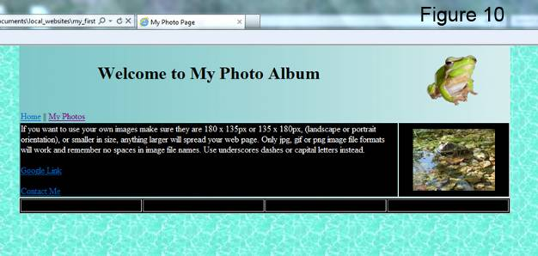

You could change the background color in the table or hide the borders to suit your design.

Step 5: Creating a photo album

In this step we insert and link 4 thumbnail (small) images which when clicked on the web page will show an enlarged view of the thumbnail image.

1. Saving web optimized images into your web page root folder

Thumbnail images can be up to 200x150 pixels (or 150x200 pixels portrait orientation) in size and images for the enlarged view of the same photo should be 400x300 pixels up to 800x600 pixels. File size for a small image should be less than 25 KB and less than 250 for the large image. Remember no spaces or special characters in image file names. Use hyphens or underscores. Only JPG, GIF and PNG file formats will work on the internet.

You can prepare web optimized photos using our Picasa Image Tutorial or other photo editors and save them into the my_first_web_page root folder. You can also copy and paste more images from our web site. See next page for instructions.
All images on our web site are copyright and only to be used for study and private purposes.
(Picasa is a free Google Image Editor; see other tutorials at end of this document)
2. Downloading images from our web site

How to download and save thumbnail images from our web site is explained in the basic html tutorial part 1. Here we use 4 small flower images from our website and 4 full size images to show the enlarged view when clicked.

Go to:
http://www.allcreativedesigns.com.au/pages/gallFlowers2.html

When downloading a thumbnail image, rename it to something simple when saving and include a reference to the small size i.e. orchid4_tn (=thumbnail):
1. Left click the same image and a full size photo will appear
2. Right click the large photo
3. Select Save picture as…
4. Navigate to your web folder
5. Rename the image; here we use orchid4_fs with fs indicating the full size image
6. Click Save

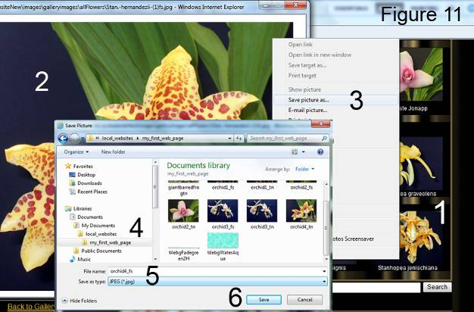

After saving the images your my_first_web_page root folder should look similar to the graphic below.
(See Figure 12)

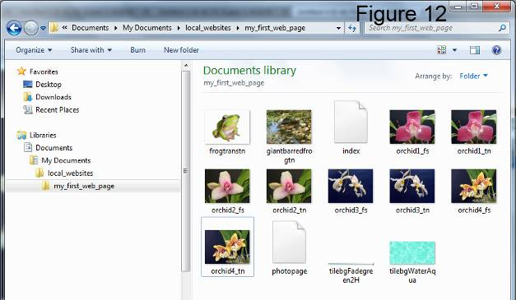

3. Inserting thumbnail images

Delete line break <br /> tags and insert images tags for your small thumbnail photos surrounded by center tags. Only type text shown in green.

<tr bgcolor=”black”
<td><center><img src="orchid1_tn.jpg" /></center></td>
<td><center><img src="orchid2_tn.jpg" /></center></td>
<td><center><img src="orchid3_tn.jpg" /></center></td>
<td><center><img src="orchid4_tn.jpg" /></center></td>
</tr>

If you are using your own images make sure of identical spelling and don’t forget the right file extension.

(See Figure 13 on next page)
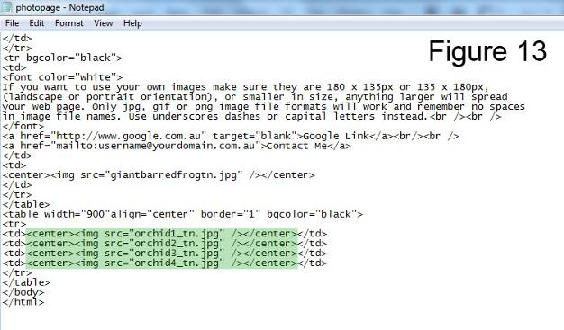

In your notepad photopage.html document click File in top menu bar and click save.

In windows explorer (My Computer) navigate to your my_first_web_page folder and double left click your photopage.html file to view your updated web page. If your web page is still open in your internet browser just click refresh.

(See Figure 14)

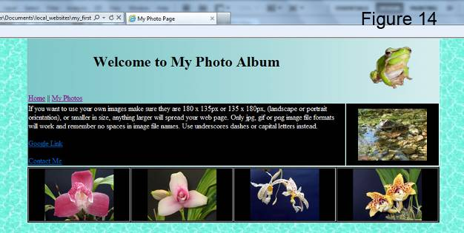

Your web page should look similar to this.
4. Hyper linking your images

We will be using the small images (just inserted) as hyperlinks to our full sized images, in the same way we used text as page links when clicked. (i.e. Home || My Photos)
When your thumbnail images are clicked on the web page an enlarged view of your photo opens.
To do this surround the thumbnail image tag with a hyperlink <a href=” ”> </a> tag. In the href reference type the image file name of your large photo within the inverted comas. Include the parameter of target=”blank” if you like your large photo to open up in a new browser window.
<tr>
<td><center><a href="orchid1_fs.jpg" target="blank"><img src="orchid1_tn.jpg" /></a></center></td>
<td><center><img src="orchid2_tn.jpg" /></center></td>
<td><center><img src="orchid3_tn.jpg" /></center></td>
<td><center><img src="orchid4_tn.jpg" /></center></td>
</tr>
(See Figure 15)
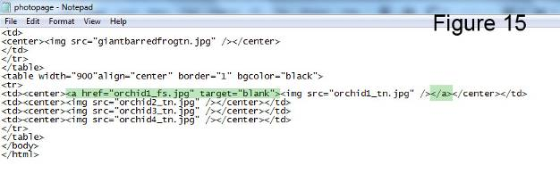
Before you repeat the process with the other images check if your hyperlink is working.

In your notepad photopage.html document click File in top menu bar and click save.

In windows explorer (My Computer) navigate to your my_first_web_page folder and double left click your photopage.html, there click the first thumbnail image.
(See Figure 16)
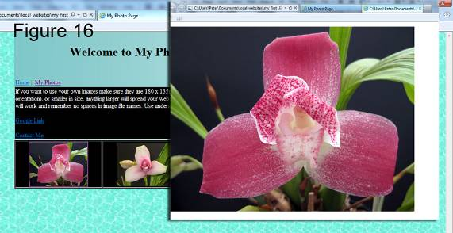
5. Trouble Shooting:

Cannot find error message:
Here the file extension .jpg for the enlarged image is missing. Also check your file path to make sure your photo is saved in the root folder of your web site. Ensure identical spelling of the image file name in your web folder with the one you used in the hyper link reference. Check that you have used the right image file extension (.jpg, .gif or .png)
(See Figure 17)

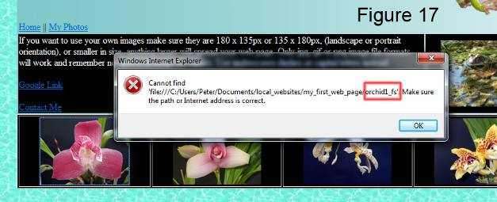

If your hyperlink for the first image is working repeat the process with the remaining photos.

6. Inserting a row for descriptions or titles:

This step will insert a new row beneath your images to hold titles or descriptions. Under the last closing row tag insert the code shown in green below. The background color of the row is to white so black text is visible. Change the text in between center tags to suit.

<td><center><a href="orchid4_fs.jpg" target="blank"><img src="orchid4_tn.jpg" /></a></center></td>
</tr>
<tr bgcolor="white">
<td><center>Orchid 1</center></td>
<td><center>Orchid 2</center></td>
<td><center>Orchid 3</center></td>
<td><center>Orchid 4</center></td>
</tr>
</table>

(See Figure 18 on the next page)
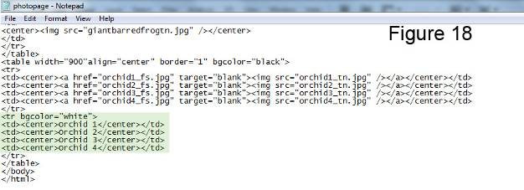

In your notepad photopage.html document click File in top menu bar and click save.

In windows explorer (My Computer) navigate to your my_first_web_page folder and double left click your photopage.html.

Your photo album web page should look similar to the graphic below.
(See Figure 19)

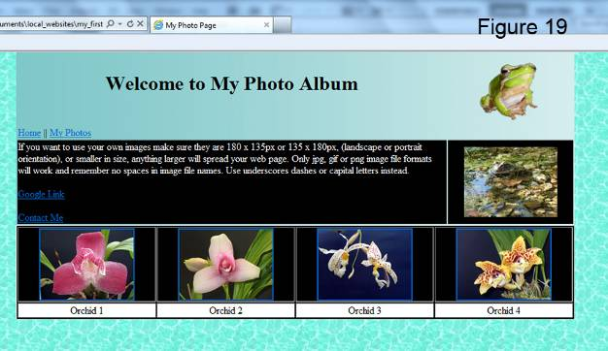

Repeat steps 5.1 to 5.6 to create your own photo album.
If you don’t want colored hyperlink borders to appear around the thumbnail images add border”0” to the image tag:

<td><center><a href="orchid1_fs.jpg" target="blank"><img src="orchid1_tn.jpg" border="0" /></a></center></td>
Finished photopage.html notepad document:
(See Figure 20)

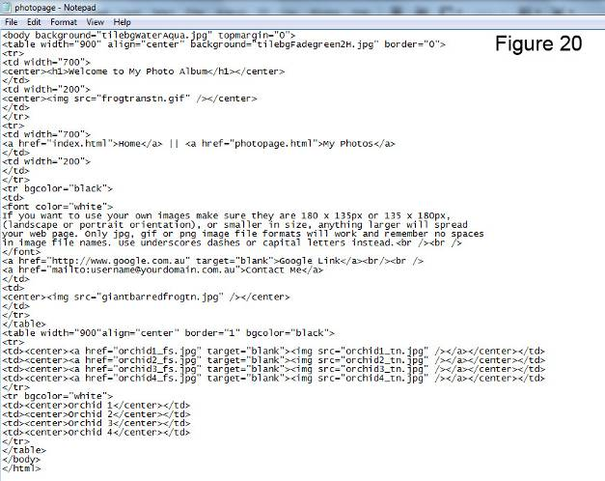

Specifying color by Hexadecimal Code

The combination of Red, Green, and Blue color values (RGB).
Where ff stands for maximum and 00 for minimum (zero) values

Red Green Blue
ff 00 00
Will show a strong red

bgcolor="#ff0000" = red
bgcolor="#00ff00" = green
bgcolor="#0000ff" = blue
bgcolor="#000000" = black
bgcolor="#ffffff" = white

Find out more about web safe colors at:
www.w3schools.com/html/html_colors.asp

More useful HTML tags

Description | Actual Code | Explanation
Paragraph tag | <p> Your text </p> | Opens and closes a paragraph in your text and add spaces above and below
Horizontal rule | <hr /> | Inserts dividing line, no closing tag
Bold text | <b>bold text </b> | All text in between tags turns bold
Italic text | <i>italic text </i> | All text in between tags turns italic
Font type | <font face="verdana">verdana</font> | Changes font to Verdana *
Font size | <font size=”2”>AA </font> | Changes font size, values are;  1(smallest) to 7 (largest)
Unordered list open | <ul> | Opens unordered list
First item in list | <li>first</li> | Opens and closes first item in list
Second item in list | <li>second</li> | Opens and closes second item in list
Unordered list closed | </ul> | Closes unordered list
* There are only a few font faces which are displayed in any internet browser. Arial will work
Default font is Times New Roman.

For a full list of HTML tags go to:
http://www.w3schools.com/tags/default.asp

Trouble Shooting:

Your script might not work properly if you copied and pasted html tags from MS Word.
My image(s) will not show :
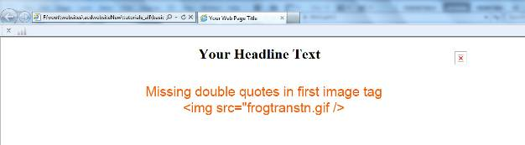
X
Possible causes:
1. Missing or incorrect quotes
2. Spelling mistakes or spaces in file names
3. Wrong file extension i.e. .jpg instead of .gif
4. Images are not saved in the same folder than your index.html file
5. Used double typed single quotes/apostrophes instead of inverted commas/double quotes
Inverted commas/double quotes on your keyboard
Positioning of elements incorrect:
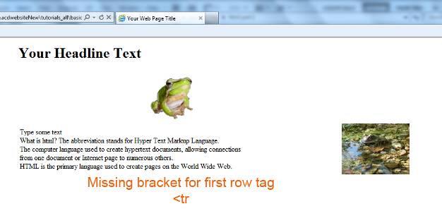
Possible causes:
1. Missing bracket for tags
2. No forward slash in closing tag
3. Incorrect spelling or spaces within html tags
4. Used double apostrophes instead of inverted comas

Most errors are caused by spelling mistakes and added or missing spaces in HTML tags. Check for missing inverted comas and closing tags.

If you find mistakes in your index.html code make the necessary changes and save again. If your web page is still open in your browser just click refresh otherwise reopen your web page.

Other tutorials available
from: www.allcreativedesigns.com.au

www.allcreativedesigns.com.au/pages/tutorialbasicp1.html
HTML Web Page Tutorial using Notepad, PDF Download Page Part 1

www.allcreativedesigns.com.au/pages/tutorialbasicp2.html
Free PDF HTML Tag Tutorial using Notepad, Download Page Part 2

www.allcreativedesigns.com.au/pages/webtutorialkompozer.html
Web Design Tutorial using KompoZer, PDF Download Page

www.allcreativedesigns.com.au/pages/tutorialpicasa.html
Picasa Photo Editing Tutorial, Free PDF Download Page

www.allcreativedesigns.com.au/pages/tutorialseo.html
SEO Tutorial Basic Search Engine Optimization PDF Download Page

